Software Engineering Tools Lab
Assignment No-1
Module 2- Software Development Frameworks
PRN : 2020BTECS00066
Batch : T7

Differentiate in between free software, Open source software and proprietary software with
respect to its properties.

What is Free Software?

Free software is a type of software that gives its users the right to run, copy, distribute, study, change and improve the software. Hence, free software is more related to freedom than price so think of it as freedom of speech rather than free lunch.
It is also called libre software where “libre” means freedom. Moreover, with free software, you even have the right to sell the software for money.
Examples: Apache Web Server, MySQL RDBMS, etc.
Every open-source software is not free software.

The main difference between open source and free software is that open source emphasizes the availability of the source code and the rights of users to modify and distribute it, while free software emphasizes that the software can be obtained and used without cost.

Every free software is open source.
Every open-source software is not free software.
Every open-source software is not free software.t free
soft
There are many different open-source software licenses, and some of them are quite restricted, resulting in open-source software that is not free.ware.
There is no such issue that exists in free software.

Examples: The Free Software Directory maintains a large database of free software packages. Some of the best-known examples include the Linux kernel, the BSD and Linux operating systems, the GNU Compiler Collection and C library; the MySQL relational database; the Apache web server; and the Sendmail mail transport agent.

Examples: Prime examples of open-source products are the Apache HTTP Server, the e-commerce platform Open Source Commerce, internet browsers Mozilla Firefox, and Chromium (the project where the vast majority of development of the freeware Google Chrome is done), and the full office suite LibreOffice.

1. Open source Software:

Open source software is computer software whose source code is available openly on the internet and programmers can modify it to add new features and capabilities without any cost. Here the software is developed and tested through open collaboration. This software is managed by an open-source community of developers. It provides community support, as well as commercial support, which is available for maintenance. We can get it for free of cost. This software also sometimes comes with a license and sometimes does not. This license provides some rights to users.

The software can be used for any purpose
Allows to study how the software works
Freedom to modify and improve the program
No restrictions on redistribution
Some examples of Open source software include Android, Ubuntu, Firefox, Open Office, etc.

2. Proprietary Software: Proprietary software is computer software where the source codes are publicly not available only the company that has created them can modify it. Here the software is developed and tested by the individual or organization by which it is owned not by the public. This software is managed by a closed team of individuals or groups that developed it. We have to pay to get this software and its commercial support is available for maintenance. The company gives a valid and authenticated license to the users to use this software. But this license puts some restrictions on users also like.

Number of installations of this software into computers
Restrictions on sharing of software illegally
Time period up to which software will operate
Number of features allowed to use
Some examples of Proprietary software include Windows, macOS, Internet Explorer, Google Earth, Microsoft Office, etc.

S.No. | OPEN-SOURCE SOFTWARE | PROPRIETARY SOFTWARE
01. | Open-source software is computer software whose source code is available openly on the internet and programmers can modify it to add new features and capabilities without any cost. | Proprietary software is computer software where the source codes are publicly not available only the company which has created can modify it.
02. | Here the software is developed and tested through open collaboration. | Here the software is developed and tested by the individual or organization by which it is owned not by the public.
03. | In open-source software the source code is public. | In proprietary software, the source code is protected.
04. | Open-source software can be installed on any computer. | Proprietary software can not be installed into any computer without a valid license.
05. | Users do not need to have any authenticated license to use this software. | Users need to have a valid and authenticated license to use this software.
06. | Open-source software is managed by an open-source community of developers. | Proprietary software is managed by a closed team of individuals or groups that developed it.
07. | It is more flexible and provides more freedom which encourages innovation. | It is not much flexible so there is a very limited innovation scope with the restrictions.
08. | Users can get open software free of charge. | Users must have to pay to get the proprietary software.
09. | In open-source software faster fixes of bugs and better security are availed due to the community. | In proprietary software, the vendor is completely responsible for fixing malfunctions.
10. | Limited Intellectual Property Protections | Full Intellectual Property Protections
11. | Usually Developed and Maintained by non-profit organizations. | Usually Developed and Maintained by for-profit entities.
12. | Examples are Android, Linux, Firefox, Open Office, GIMP, VLC Media player, etc. | Examples are Windows, macOS, Internet Explorer, Google Earth, Microsoft Office, Adobe Flash Player, Skype, etc.

2. Enlist some examples along with its purpose and properties (at least 10) of FOSS and
proprietary software with respect to database.

1 PostgreSQL
PostgreSQL is an object-relational database management system, founded on July 8, 1996. Developed by the PostgreSQL Global Development Group, it is written in C and works in most UNIX-like operating systems and Windows.

Features

a. PostgreSQL works with every significant language and middleware.

b. It bolsters simultaneous control.

c. Its server-side programming usefulness is extremely full-grown.

d. It has support for JSON licences.

2 MariaDB
MariaDB is a network created relational database management software system, written in C, C++, Bash and Perl. The stable version 10.3.12 of this free and open source database management software has the date January 7, 2019. MariaDB Corporation AB and MariaDB Foundation are the developers of this database.

Features

a. MariaDB is comparable to MySQL, with some additional features. It can be viewed as an evolved variant of MySQL.

b. Programming in MariaDB is covered by BSD, GPL, and LGPL licences.

c. The framework uses a rearranged and standard questioning language.

d. It supports an assortment of working frameworks and programming dialects.

e. It offers special help for PHP.

3 CockroachDB
CockroachDB is a distributed SQL (newSQL) database built on a transactional and strongly-consistent key-value store. It’s heavily inspired by Google’s Spanner and has many similarities with it.

Features

a. Distributed or replicated OLTP

b. Multi-data centre deployments

c. Multi-region deployments

d. Cloud migrations

e. Cloud-native infrastructure initiatives

4 Neo4j
Neo4j is a graph database management system. Its stable version 3.5.1 was released on December 20, 2018.

Features

a. It is ACID (atomicity, consistency, isolation, and durability) compliant.

b. It encourages versatility.

c. Replicates information with quality and security.

d. It works with Web applications for recovering chart information.

e. It bolsters enquiry information sent out to JSON and XLS design.

5 CouchDB
CouchDB has been developed by the Apache Software Foundation, and is written in Erlang language. The stable version 2.3.0 was released on December 6, 2018.

Features

a. It is ACID compliant.

b. Has a distributed design with replication.

c. CouchDB gives accessibility such as parcel resilience, ensuring competency.

d. The information in the CouchDB framework is stored as ‘records’.

6 RethinkDB
RethinkDB is an open source database that, in contrast to customary database frameworks, stores data in the JSON (JavaScript Object Notation) group. It’s viewed as a NoSQL (Not only SQL) database, just like MongoDB, Cassandra, and CouchDB.

Features

a. No mapping or table structure is required for putting away the data.

b. Distributed engineering helps it to scale (in groups).

c. It has:

Consistency (similar information can be viewed by all the customers of the framework)
Availability
Partition tolerance
7 Redis
Redis is an open source (BSD authorised), in-memory information structure store, used as a database, reserve and message dealer. It enhances information structures — for example, strings, hashes, records, sets, arranged sets with extend enquiries, bitmaps, hyperlogs, and geospatial files.

Features

a. In-memory data store

b. Flexible data structures

c. Simplicity and ease-of-use

d. Replication and persistence

e. High availability and scalability

8 SQLite
SQLite is a C programming library. The word ‘lite’ in the name indicates that the organisation, arrangement, and basic source of the database is lightweight. Created by D. Richard Hipp on August 17, 2000, the stable version of SQLite 3.26.0 was released on December 1, 2018.

Features

a. SQLite programming enhances cross-stage document design.

b. It needs less programming. The whole library is under 500 KiB in size.

c. It has a static composing group, which is usable in most SQL database motors.

d. SQLite utilises variable-length records.

e. The SQL explanations are compiled into virtual machine code.

9 Cassandra
Cassandra comes from the stable of the Apache Software Foundation, and is a free and open source DBMS written in Java. Authorised under Apache License 2.0, its stable version 3.11.3 was released on August 1, 2018.

Features

a. Apache Cassandra is a NoSQL database.

b. It supports replication and multi-server farm replication.

c. It is adaptable and reliable.

d. A distributed database, its conveyance plan relies on Amazon DynamoDB and information model on Google Cloud Bigtable.

e. Cassandra can run on sensitive equipment and perform quick writes to store a lot of information.

10 Timescale
New technologies require new sorts of databases. One of the best open source databases for the Internet of Things is Timescale.

Features

a. Hypertable abstraction layer

b. Automatic partitioning

c. Optimised time based constraint exclusion

d. Works across time-series and relational tables

e. Built-in flexible time bucketing

3. Enlist some examples of free open source exam software for online assessment.
TCExam
VirtualX
Moodle
TAO
Kaldin
Papershala
Edbase
Mettl
FlexiQuiz
Eklavvya
Think Exam

4. Demonstrate any one exam software which is open source and freely available.

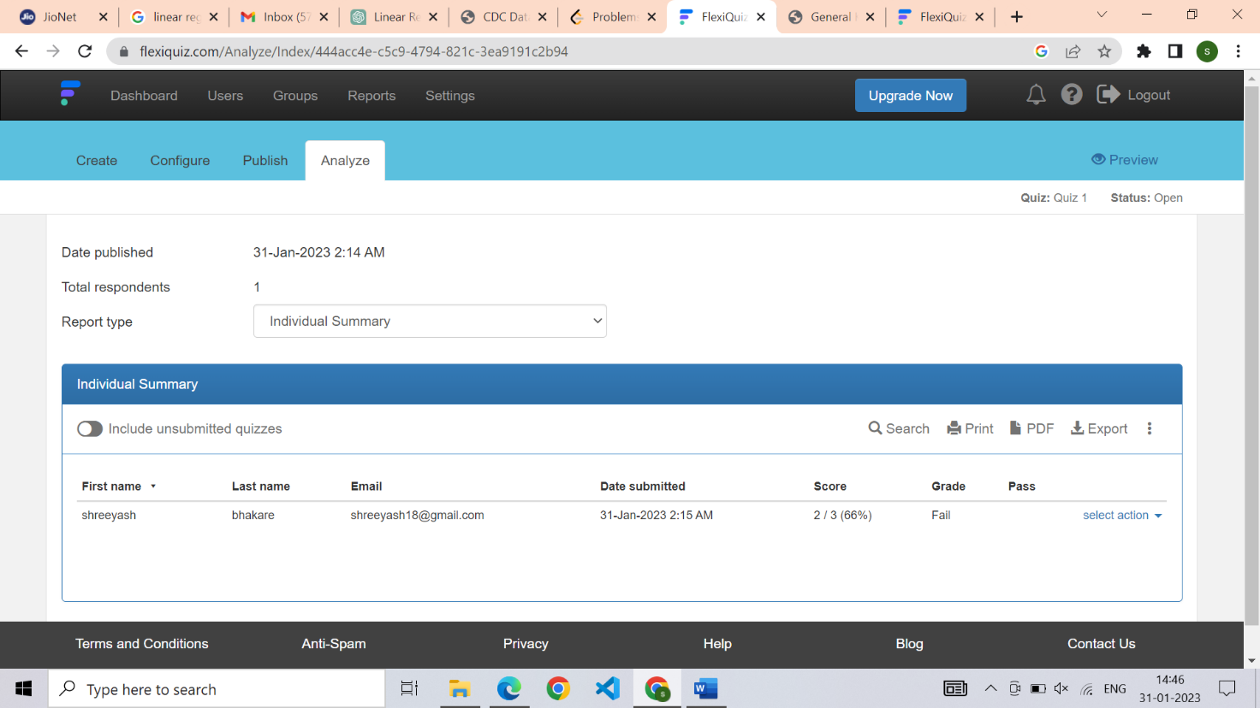

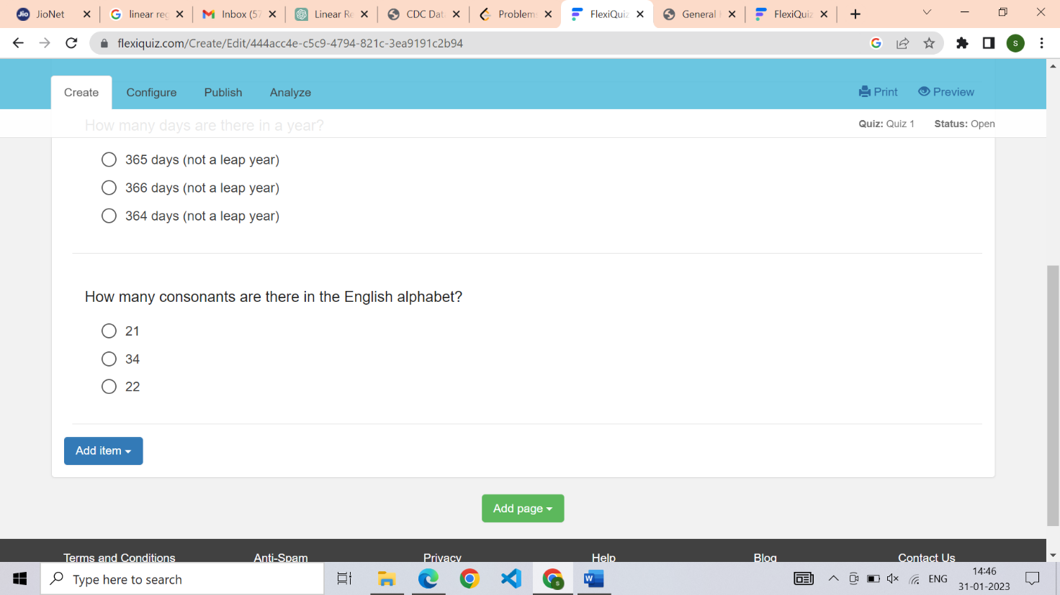

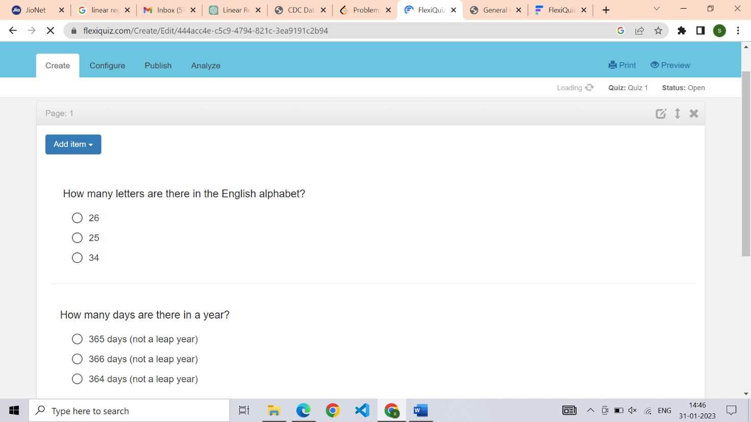

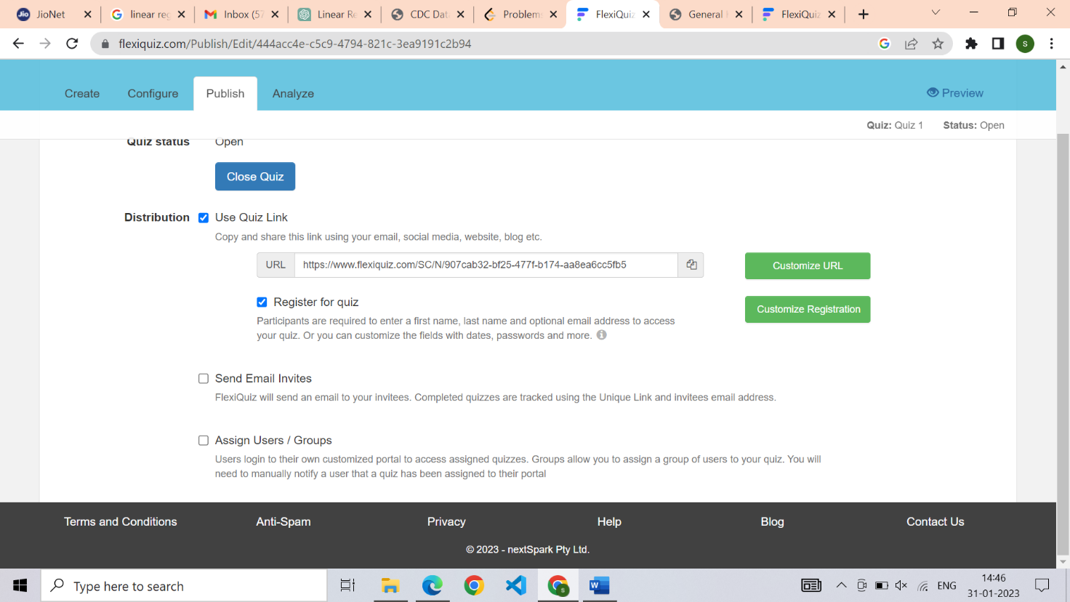

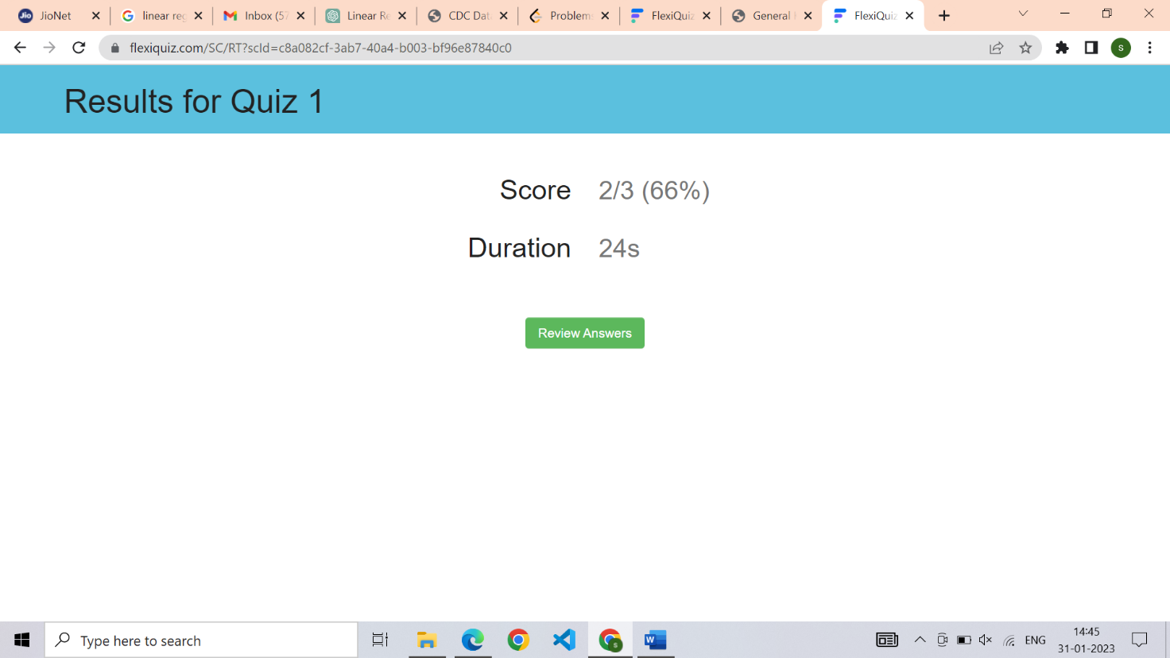
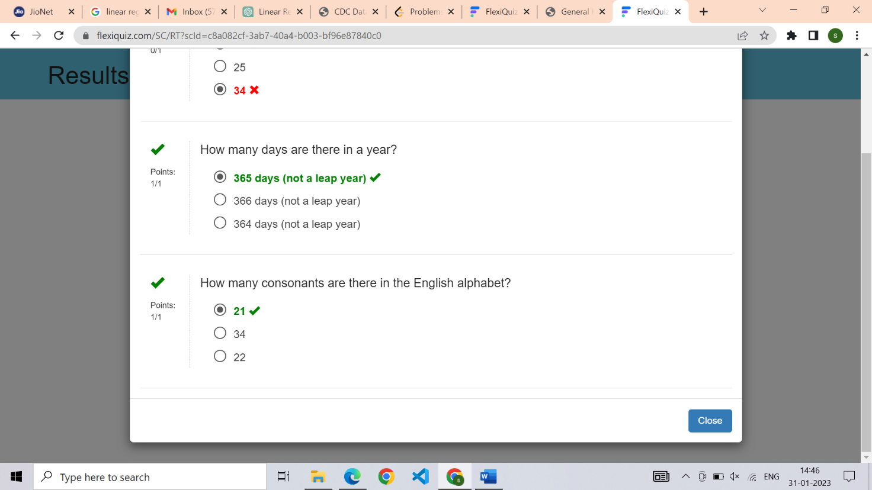

6. How does the Exam software work?

FlexiQuiz is an online exam software that allows users to create and administer exams, quizzes, and surveys. It works by providing an interface for creating questions and distributing exams to a target audience. The software tracks results, analyzes performance, and provides reports and insights for further analysis. The exams can be taken on any device with internet access, and the software can be customized to meet specific needs and requirements.

5. Demonstrate FOSS software related to database.

-→>>> Mongodb

